Fee Structure for all Diploma Courses
ROHITASH INSITITUTE OF ENGG. & TECHNOLOGY

Sr. | Institute Name | Tution fee | Dev Fee | Total
1 | Rohitash Institute of Engg. & Technology Ateli | 17500 | 5000 | 22500

Admission Policy
- First Year and Direct Second Year admissions are made by strictly following the guidelines issued by the Directorate of Technical Education (HSBTE), Government of Haryana and All India Council for Technical Education (AICTE), New Delhi (Refer Prospectus in Admission Form).
- Admission related advertisements are given in leading dailies to create awareness among the general public. Our polytechnic college website also displays admission related information.
- Separate counters are opened in the office for the purpose of issuing applications and prospectus.
Eligible students will apply for courses by submitting duly filled in applications.
- After the cut-off date, the received applications are scrutinized and a rank list is prepared based on communal reservation (As per Govt. policy). This will be followed by counselling process.
- Counselling Call letters are sent as per the above rank order. Counselling will be conducted in the presence of HSBTE nominee.
- Proper instructions and merits of each course are orally explained by the Principal before the start of counselling to parents and students.
- The admitted studentsâ€™ data are uploaded in HDBTE and AICTE Portals.
- After receiving the approved students list from DHSBTE, nominal role is prepared for examination, award of scholarship and other students related activities.

Reservation policy
Selection shall be made under five categories following the rules of reservation inforce at the time of publication of the selection list.
- Open Competition (31%)
- EWS (10%)
- Backward Class (26.5%)
- MBC/DNC (16.5%)
- Schedule Caste (15%)
- Schedule Tribe (1%)
Candidates seeking admission against ST/SC/SC(A)/MBC&DNC/BC(Others)/BC(Muslims) quota should obtain the certificate of social status in the prescribed permanent community cards and produce at the time of admission.
For Communities linked with Districts the candidate should obtain their Community Certificate in the respective districts only.
Note :
- No persons who professes a religion different from Hinduism or Sikhism shall be deemed to be a member of a Scheduled Caste.
- A member of the Scheduled Caste on conversion to Christianity will be considered only under Backward class Christian and not under Scheduled caste, for admission purposes.
- A member of the Scheduled Tribe will however continue to be treated as such a member irrespective of whether he/she is a convert to any religion or is a dicondent of such a convert.
- A candidate who claims to belong to Scheduled Caste by virtue of reconversion should give full details regarding dateof reconversion and whether the candidate on such reconversion is accepted by members of the particular community of the locality where he/she resides as belonging to that particular community which he/she claims to be and submit the copy of relevant certificate for reconversion for competent authority and the copy of Gazette notification to the effect.
- ST / SC / SC(A) / MBC & DNC / BC (Others) / BC (Muslims) candidates are eligible for selection under Open Competition in addition to the reservations made for them.
- The ST candidates should obtain the Community Certificates only from the, RDO or Sub Collector or Assistant Collector of their native division or Collector of their Districts or P.A. (General) to Collector of Chennai.
- Candidates are warned that if the community recorded in the certificate producedby them, even though issued by competent authority is not included in the list of ST/SC/SC(A)/MBC&DNC/ BC(Others)/BC(Muslims) or if the community certificate is not issued/signed by the competent authority or if the community certificate is not in the form of the Permanent Community Card. They will not be considered as belong to ST / SC / SC (A) / MBC & DNC / BC(Others) / BC(Muslims) as the case may be. They will beconsidered only as “OTHER COMMUNITIES” and privileges that have been given on the presumption that the candidates belong to ST / SC / SC(A) / MBC & DNC / BC (Others) / BC(Muslims) will be withdrawn.
No correspondence in this connection will be entertained.

DOCUMENT RETENTION POLICY

Document Type | Retention Period
Administrative Records
Employee Certificates | Retained in office till He/She leaves the institution
Purchase bills and vouchers | Permanent
Stock Register for Lab | Permanent
Stock Register for Library | Permanent
Employee Attendance | Permanent
Employee Acquittance | Permanent
Accounts/Audit/Bank Statements | Permanent
Employee Insurance | Permanent
Student Group Insurance | Permanent
Admission Records
Application | Permanent
Transfer Certificate | Permanent
Marksheet | Retained in office till He/She leaves the institution
Diploma Certificate | Retained in office till He/She leaves the institution
Provisional Certificate | Retained in office till He/She leaves the institution
Academic Records
Test Papers | 2 Years
Assignments | 2 Years
Library Books | Permanent
Email | Permanent
Placement Records
Placement Records | 2 Years
Examination Records
Nominal Roll | Permanent
Consolidated Result | Permanent
Institution Letters | Permanent
Syllabus | Permanent
Staff Joining Letters | Permanent
Central Valuation Letters | Permanent
Detained,Re-admission Records | Permanent
Internal Marks | Permanent
Staff Circular | Permanent
Student Circular | Permanent

Following Courses Intake indicated below

Program | Level | Course | Affiliating Body (University  /Body) | Intake Approved for 2019-20 | Intake Approved for 2020-21
ENGINEERING AND TECHNOLOGY | DIPLOMA | MECHANICAL ENGINEERING | Directorate of Technical Education | 45 | 45
ENGINEERING AND TECHNOLOGY | DIPLOMA | MECHANICAL ENGINEERING (TOOL & DIE) | Directorate of Technical Education | 45 | 45
ENGINEERING AND TECHNOLOGY | DIPLOMA | Electronics and Communication Engineering (Microwaves) | Directorate of Technical Education | 45 | 45
ENGINEERING AND TECHNOLOGY | DIPLOMA | ELECTRICAL ENGINEERING | Directorate of Technical Education | 45 | 45
ENGINEERING AND TECHNOLOGY | DIPLOMA | COMPUTER ENGINEERING | Directorate of Technical Education | 45 | 45
ENGINEERING AND TECHNOLOGY | DIPLOMA | CIVIL ENGINEERING | Directorate of Technical Education | 45 | 45

ROHITASH INSTITUTE OF ENGG. & TECHNOLOGY ATELI MANDI

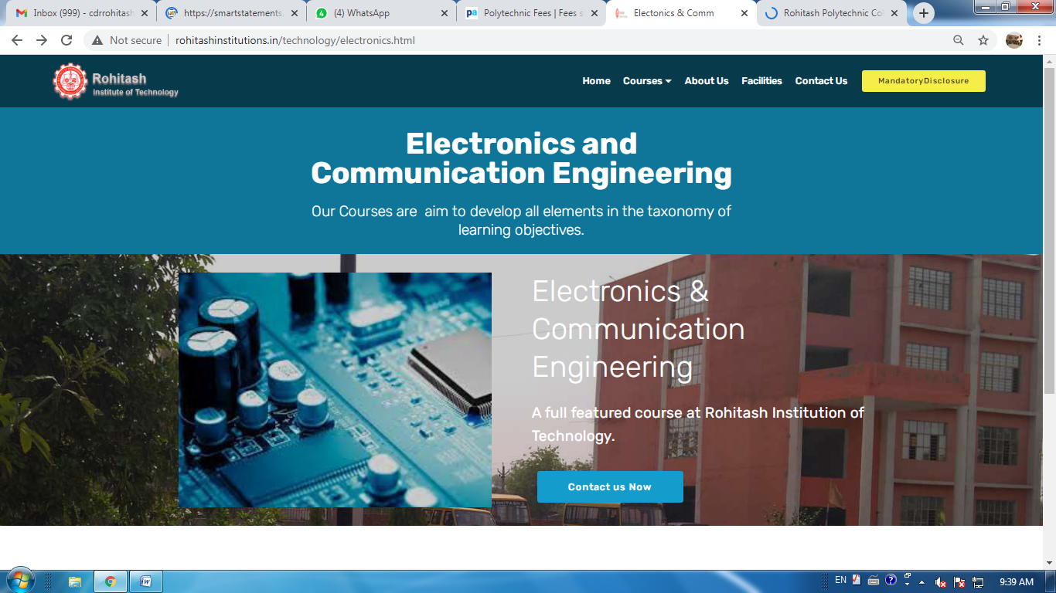
Web Site:- http://rohitashinstitutions.in/technology/electronics.html

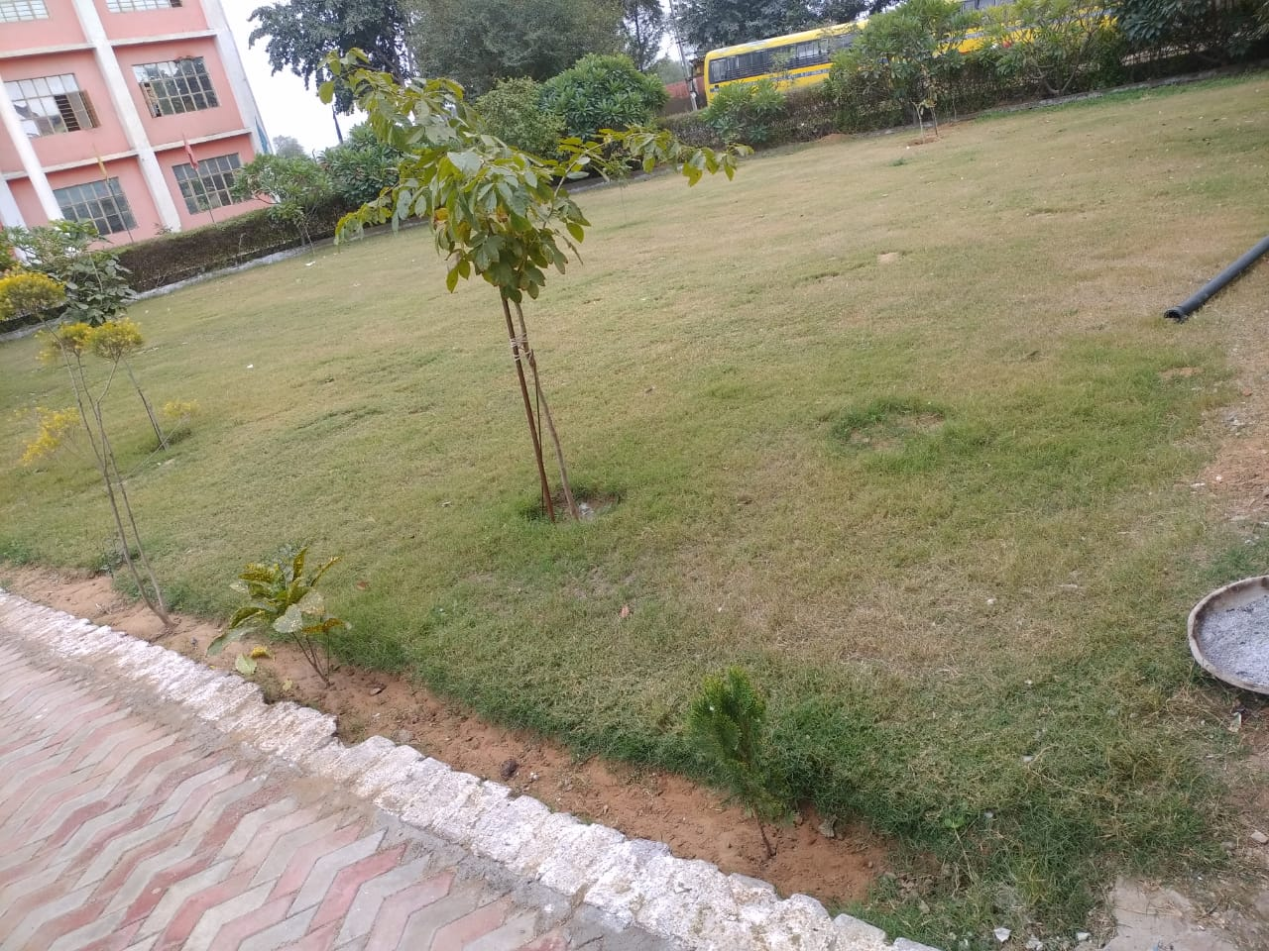
GREEN COMPUS AND WASTE MANAGEMENT

